  - Chatham-Kent Coin Club


Vol 1 Issue 1 January 2026

President: Jim Austin
Editor: CKCC Executive
CKCoinClub.com
Newsletter@CKCoinClub.com
Published: Monthly
Next meeting is January 21, 2026 at John McGregor Secondary School Library, 300 Cecile Avenue Chatham

Inside this Issue
Page 1 Presidents message
Page 2 Report of the Secretary
Page 4 2025 TOONIE: TOMB OF THE UNKNOWN SOLDIER

Page 6 Canadian Shinplaster Notes: History, Production, and Design
Page 8 Provincial Shinplaster Issues in Canada
Page 9 Buy, Sell & Trade

Presidents Message:
WHAT’s going on

Welcome to our new newsletter.

Each issue will have at least one article on some aspect of Numismatics.
It is our hope you will find it informative.

As we grow, we will most likely be making changes to the layout and content. If you have any
suggestions or ideas to improve this newsletter, please let us know at Newsletter@CKCoins.Com

We are looking for article contributions, so if you have an article you would like to see included, please forward it to us at the same address.

Before I go any further, I hope you all had a great Christmas and a very fun New Years. Did any one get new coins for Christmas?
We are now into January, so I must remind any one who has not paid their dues, to contact Paul Robb to do so. He can be reached at 289-228-2817.

Also, we are still looking for a couple good people to help us (wo)man our booth on January 18. Please contact me at 226-627-6789 if you can put in a couple hours; either the morning or afternoon. It runs from 9 until 3. You do need a red “Committee” shirt to work it. You will have time to walk the floor to visit the other displays.
Happy Coin Collecting,
Jim Austin

Report of the Secretary:
Meeting Notes from #607 Dec 17th 2025
The meeting was brought to order by President Jim Austin with 21 members in attendance. Jim’s first order of business as our newly elected president, was to thank outgoing President Paul Robb for the many years of service he gave to the club and will continue giving as treasurer. Jim reminded the membership that our annual dues are due. Please see Treasurer Paul Robb if you haven’t paid them. Jim also thanked Paul for obtaining the Christmas treats that we enjoyed during the meeting to celebrate the season.
Paul announced that we are sold out for the tables at our March 29th 2026 coin show to be held at the Everest Convention Center. Since this is our second year at this venue, and with lessons learned from last year we anticipate a very smooth, well run show. Paul reminded all new members that we like to have all volunteers at the show to wear a red “Committee shirt” so that we are visible to assist dealers and visitors alike at the show. Please see Paul to order one of these shirts, as Paul will be putting in a new shirt order in January. We also offer many other colours in short and long sleeved styles for purchase.
Colin Cutler announced that he received close to 170 coins for grading at ICCS. This allows us to obtain “bulk pricing” ($12 plus tax per coin) for the grading. We thank Colin for organizing this valuable project. Coordinating as group saves on the grading cost for each coin. Colin will personally take the coins to ICCS in early January and pick them up when complete. This is usually about eight weeks.
Jim talked about having a “Metal Detection” group in for a talk in 2026, and asked if there was interest. This group recently gave a talk to the Windsor Coin club, which they thought it was worthwhile. There is enough interest and Jim will try to book something for Feb or March. With the presentation, they also bring in items to sell to get you started in the hobby. If you ever thought this is something that might interest you, you will gain knowledge of the hobby and the necessary equipment.
One area of interest for collecting for Dennis Maceyovski is Japanese Invasion money. We coordinated with Dennis and had a slide presentation about the history, and reasons why the Japanese Invasion money existed in so many countries, currencies and denominations. Once the presentation was complete, we were able to see and touch firsthand the 50 different notes Dennis has in his collection.

Raffle: Chris Hulett
Door Prize: Jeff Webb

Jim Austin contact info: President@CKCoinClub.com 226-627-6789

2025 Toonie: Tomb of the Unknown Soldier
Commemorating Sacrifice and Remembrance in Canadian Coinage
By Jim Austin
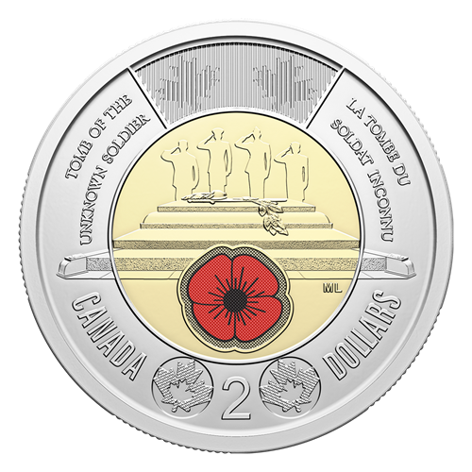
The 2025 Toonie (the Canadian two-dollar coin) commemorates the centennial of the Tomb of the Unknown Soldier, a significant national symbol located in Ottawa, Canada. This special edition coin was released by the Royal Canadian Mint to honor the memory of all unidentified soldiers who have made the ultimate sacrifice in service to Canada.

Design Features
The 2025 Toonie features imagery inspired by the Tomb of the Unknown Soldier, including visual elements such as the tomb itself, poppies, and motifs representing remembrance and military service. The design is meant to evoke reflection on the cost of war and the importance of honoring those whose
names and stories remain unknown but
whose sacrifice is deeply valued by the nation.

Reason for Minting
This commemorative coin was minted to mark the 100th anniversary of the establishment of the Tomb of the
Unknown Soldier in 1925. The tomb
serves as a symbolic resting place for all
Canadian soldiers who lost their lives and
whose remains were never identified. By issuing this Toonie, the Royal Canadian Mint aims to foster national remembrance, encourage reflection on the sacrifices made during conflicts, and reinforce the nation's commitment to honoring its fallen heroes.

Mintage Statistics
While official mintage figures can vary depending on final production and demand, limited edition commemorative coins such as the 2025 Tomb of the Unknown Soldier Toonie are typically produced in both circulation and collector versions. As an example, the Royal Canadian Mint often issues several million of the circulation coins, while
collector versions (such as proof editions) are minted in much smaller quantities, sometimes in the tens or hundreds of thousands. For the most accurate and up-to-date mintage statistics, it is recommended to consult the official Royal Canadian Mint website or annual reports once final figures are released.
Mintage: 15,000 Special Wrap Rolls Coloured
10,000 Special Wrap Rolls non-Coloured
Weight: 6.99 g
Diameter: 28 mm
Finish: Circulation
Composition: Outer ring: Three-ply nickel-plated steel; Inner core: Three-ply brass-plated aluminum bronze with selective colour
Artist: Mary-Ann Liu (reverse), Steven Rosati (obverse)

Significance
The 2025 Tomb of the Unknown Soldier Toonie serves not only as legal tender but also as a piece of national heritage. By carrying this coin, Canadians are reminded daily of the sacrifices made by their military and the enduring importance of remembrance in preserving the nation's history and values.

Did you know:
The Chatham-Kent Coin Club was formed in 1963 as the
Kent Coin Club

Canadian Shinplaster Notes: History, Production, and Designs
  - A Comprehensive Look at Canada's Small-Denomination Currency
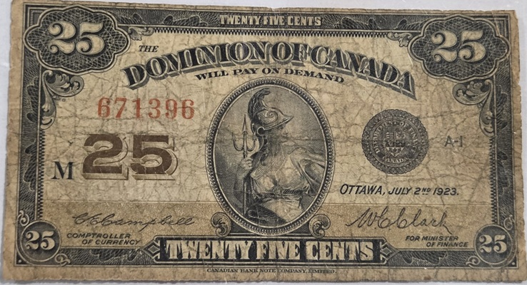
By Jim Austin

Introduction
Canadian Shinplaster notes hold a unique place in the history of Canadian currency. Serving as low-denomination paper money, these notes were essential for everyday transactions during a time when coins were scarce. This article explores where and why Shinplaster notes were printed, the years of their production, their quantity, and the distinctive designs that made them memorable.[1][2]

Where Were Shinplaster Notes Printed?
Shinplaster notes were printed in Canada by the Dominion of Canada government. The actual printing took place primarily in Ottawa, which was the administrative and political center for currency production during the late 19th and early 20th centuries.[1][3]

Why Were Shinplaster Notes Printed?
The term "shinplaster" originated in the United States and referred to small denomination, low-value paper currency. In Canada, these notes emerged out of necessity. During the late 1800s, there was a shortage of silver coins, making it difficult for Canadians to conduct everyday transactions. To address this, the government issued fractional currency notes, most commonly in the 25-cent denomination, to substitute for missing coins and facilitate commerce.[1][4]

Years of Production
The official Canadian Shinplaster notes were printed over three main periods:
- First Issue: 1870
- Second Issue: 1900
- Third Issue: 1923
Each issue addressed ongoing shortages of coinage and reflected changes in design and security features over time.[1][2]

How Many Shinplaster Notes Were Printed?
The exact quantity of Shinplaster notes printed varied by issue. For the initial 1870 issue, millions of notes were produced to address the immediate shortage. By the 1923 issue, the number had grown considerably due to increased demand and population growth. Estimates suggest that over 50 million Shinplaster notes were printed across all issues. However, many have since been lost or destroyed, making surviving specimens collectible today.[2][3]

Designs on the Shinplaster Notes
The designs of Canadian Shinplaster notes
evolved over time, reflecting both artistic trends and practical concerns such as counterfeit prevention.
- 1870 Issue: Featured a vignette of Britannia seated with a trident and shield, symbolizing strength and protection. The note included ornate borders and fine detailing.
- 1900 Issue: Showcased the portrait of Princess Patricia of Connaught, a member of the British royal family. The note included intricate scrollwork and security features.
- 1923 Issue: Depicted a young woman known as "Miss Canada," surrounded by elaborate patterns and borders. The note was designed to be visually striking and difficult to counterfeit.
Common to all issues were design elements such as bilingual text (English and French), serial numbers, and the official seal of the Dominion of Canada. The notes were small in size, which made them easy to carry and earned them the informal nickname "shinplasters."[1][4]

Conclusion
Canadian Shinplaster notes are a fascinating part of Canada's monetary history. Printed in Ottawa to address coin shortages between 1870 and 1923, more than 50 million notes were issued. Their designs ranged from Britannia and royal figures to allegorical representations of Canada, making them not only practical but also culturally significant. Today, surviving Shinplaster notes are prized by collectors and serve as reminders of a formative period in Canadian currency.[1][2][3][4]

References
- Bank of Canada Museum. "Shinplasters: Canada’s 25-Cent Notes." bankofcanadamuseum.ca
- The Canadian Encyclopedia. "Shinplaster." thecanadianencyclopedia.ca
- Banknote World. "Canada 25 Cents, Shinplaster Notes." banknoteworld.com
(continued on page 7)
- Canadian Currency Exhibit. "Dominion of Canada Fractional Notes." currency.museum.ca

Provincial Shinplaster Issues in Canada
By Jim Austin
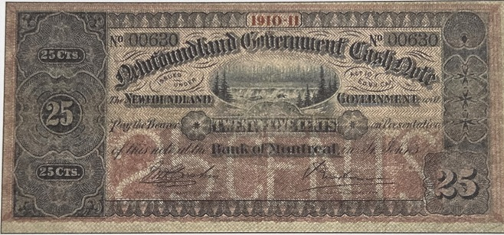

While the Dominion of Canada government was the principal issuer of shinplaster notes, the practice of printing fractional currency was not entirely confined to the federal level. In the decades before Confederation in 1867, several Canadian provinces—then known as
British North American colonies—issued their own forms of low-denomination paper money that would later be colloquially categorized as shinplasters.

Which Provinces Printed Their Own Shinplasters?
The provinces of New Brunswick, Nova Scotia, and Prince Edward Island are noteworthy for issuing their own fractional notes during the mid-19th century. These notes typically ranged in value from 5 cents to 50 cents. Such provincial shinplasters were most commonly issued between the 1830s and 1860s, prior to the unification of Canadian currency under the Dominion government.[2]

When Were Provincial Shinplasters Printed?
- New Brunswick: Issued fractional notes from the 1830s through the 1860s.
- Nova Scotia: Printed low-value notes intermittently from the 1840s to the 1860s.
- Prince Edward Island: Produced its own shinplasters, especially in the 1840s and 1850s.
Other provinces, such as Newfoundland, also printed fractional paper currency before joining Canada, although these are not always referred to as shinplasters in the strictest sense. Their issues continued into the late 19th and early 20th centuries.
(continued on page 8)

Why Did Provinces Issue Shinplaster Notes?
Several factors motivated the provinces to issue their own shinplaster notes. Chief among them was a persistent shortage of coins for everyday transactions. The remote location of some regions, the slow supply of British and foreign coinage, and fluctuations in the colonial economy made small change hard to come by. Provincial governments and local banks stepped in to fill this void by issuing their own small-denomination notes, ensuring commerce could continue smoothly. These notes were typically intended for local circulation, and their designs often reflected regional symbols or figures of importance.[2][4]

Legacy
When the Dominion of Canada standardized the currency system after Confederation, most provincial shinplaster issues were withdrawn from circulation in favor of nationally issued notes. Collectors today value surviving examples of these provincial shinplasters for their historical and regional significance, as they represent an important chapter in the evolution of Canadian money.

References
- Bank of Canada Museum. "Shinplasters: Canada’s 25-Cent Notes." bankofcanadamuseum.ca
- The Canadian Encyclopedia. "Shinplaster." thecanadianencyclopedia.ca
- Banknote World. "Canada 25 Cents, Shinplaster Notes." banknoteworld.com
- Canadian Currency Exhibit. "Dominion of Canada Fractional Notes." currency.museum.ca

Buy/Sell/Trade:
C-K Coin Club members in good standing are encouraged to submit ads for numismatic and related items.
Another ad can go here.
Wanted: Wooden money. Particularly from SW Ontario, but any from Canada. Call Jim @ 226-627-6789
Your ad can go here

