  - Chatham-Kent Coin Club

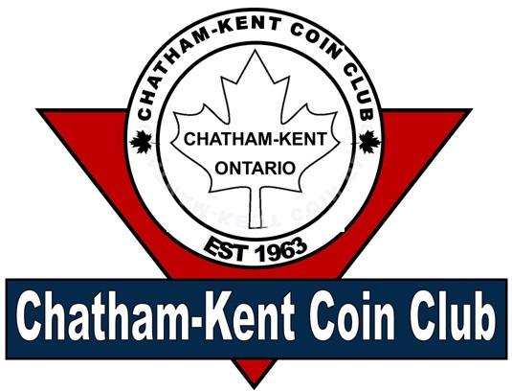
Vol 1 Issue 2 February 2026

President: Jim Austin
Editor: CKCC Executive
CKCoinClub.com
Newsletter@CKCoinClub.com
Published: Monthly
Next meeting is February 18, 2026 at John McGregor Secondary School Library, 300 Cecile Avenue Chatham

Inside this Issue
Page 1 Presidents message
Page 2 Report of the Secretary
Page 4 The Edge Lettering on Canadian Toonies (Since 2012)

Page 7 The Arnprior Silver Dollar
Page 10 Buy, Sell & Trade

Presidents Message:
WHAT’s going on

Welcome to the newsletter.

Each issue will have at least one article on some aspect of Numismatics.
It is our hope you will find the newsletter informative.

We are looking for article contributions, so if you have an article you would like to see included, please forward it to us at Newsletter@CKCoins.Com. If you wrote it, we can include it. If it was written by someone else, please provide the source so we can get permission to use it.

Our coin show is fast approaching (March 29) and you know that means we are looking for volunteers. If you are able to help, please let us know at the February meeting on February 18. Specifially, we need help at 7:00 AM on the 18th to get tables in and placed. We will only have about an hour to get them placed as the dealers need time to set up their wares. We also need volunteers who have the red “committee” shirt who can help out during the show itself, even if only half the day. Everyone will have time to walk the floor to visit all our dealers.

Lastly, Metal Detect, a local company that sells metal detectors and gear, will be at our February meeting to give a presentation on how it all works. How is this related to coin collecting, you ask? Well, many times the metal detectors find coins in varying condition. These can be added to your collection. Not only coins, but sometimes they find jewelry, some of which can be valuable. Our February meeting is open to all, so invite your friends, family and coworkers to possibly discover a new hobby.
Happy Collecting,
Jim Austin

Report of the Secretary: Richard Sadler
Meeting Notes from #608 January 21 2026

The meeting was brought to order by President Jim Austin with 19 members and two guests in attendance. Richard Sadler read the minutes from our December meeting and reminded everyone that the newsletters are now posted on our website (https://ckcoinclub.com) and not emailed out to each person as we’ve done in the past. Jim mentioned that he sent a “link email” out to each member to sign up to receive updates from the site, but there are still some members that haven’t clicked on the link. Please accept the invitation to stay informed about the club. Jim also mentioned that he is adding numismatic articles as part of the site. If you have something you’d like to add, please reach out to Jim for inclusion.
Richard also posed a question to the membership about changing our raffle ticket sales at the meeting to make the tickets one dollar each. This will make the process a bit easier and quicker without changing your odds of winning. The vote was by show of hands and the majority agreed to the change.
Colin advised that he received 193 coins which he took to ICCS for grading in early January and he should receive them completed by the middle of March.
Treasure Paul Robb gave us the financial report. With our Coin show on March 29th 2026, Paul has paid for the hall and table rental, plus to have the show flyers printed.
We are planning to rent one of the street mobile signs (approx. 4 ft X 6 ft) to promote our show like we did last year at a cost of $100, that isn’t yet paid for, but the majority of the show costs are paid, and Paul is currently receiving the table fees from the Dealers.
Paul passed out 10 show flyers to each member to have them post them around the city where they can, but please don’t post them until after Feb 15th. History shows that posting them about six weeks before the event seems to work best.
Paul also advised that the hall is rented the night before our show, so we won’t be able to set up the night before. Therefore we’ll need many hands to help set up on Sunday March 29th at 7:00 am. Paul would like to have a list of volunteers in place at the February meeting. If you’re unable to attend the meeting, but willing to help, please reach out to Paul (289-228-2817).
Paul talked about the recent Toy Show that we had a display table at. The show was well attended and Paul passed out 150 coin bags to the kids in attendance and over 300 flyers for our upcoming show.
There is a shirt order being placed in January and Paul will place another order when needed. We need a minimum of six shirts to place an order.
Rudy Boogerman gave a brief talk about a presentation on numismatics he delivered at the Alzheimers society. It was a small group, but they were very interested and attentive. The society invited Rudy to come again as they felt it was worthwhile for their group.
Jim Austin discussed that he has updated our Constitution and By-Laws to reflect our new meeting location and our name change from “Kent Coin club” to “Chatham-Kent Coin club”, and had copies available for the membership to have a copy.
Jim was happy to announce that the “Medal Detectors” group has accepted our offer to come and give us a presentation at our February meeting, and extended an invitation to the membership to bring a friend who might find this interesting. The Medal Detectors will bring information about their hobby, and items for sale to help someone get started in the hobby. Jim will put a link to their Web site on our site if you have questions or want to make a purchase from them that they could bring with them in February to our meeting.

Raffle: Rudy Boogerman
Door Prize: Marv Stamcoff

Did you know that, since 2012, there is writing on the edge of the Toonie?
Keep reading to find out more!

The Edge Lettering on Canadian Toonies (Since 2012)

By Jim Austin

Canada’s Two-Dollar Coin — The Toonie

What Changed in 2012: Edge Lettering
Starting in 2012, the Royal Canadian Mint updated its circulation coins — including the $2 Toonie — to add advanced anti-counterfeiting security features:

New Security Features
- Edge lettering with the text “CANADA” and “2 DOLLARS” engraved around the rim.
- Laser-engraved maple leaf marks in the design.
- A latent image that shifts when the coin is tilted.
- Interrupted reeding (a mix of smooth and ridged sections) on their edges — a tactile pattern to aid identification.

Why Edge Lettering Was Added
Edge lettering improved security and usability:
- Anti-Counterfeiting: Text and symbols on the edge are harder for counterfeiters to duplicate without precise equipment.
- Modern Identification: The clear denomination and country name on the edge help devices and humans confirm authenticity.
- Integrated Security Design: The lettering complements laser marks and latent imagery for layered protection.

Type A vs. Type B Edge Lettering — Close-Up Views
Because the edge lettering process is separate from the main coin strike, each coin can enter the edge press obverse-up or reverse-up. This random entry produces two orientation varieties:

Type A Edge Lettering

Letters read correctly (upright) when the obverse (Queen’s or Kings’s portrait) is facing up.
- Often shown by collectors as the standard presentation.

Type B Edge Lettering
- Letters read upside down when the obverse is facing up.
- Same coin otherwise; just rotated differently during edge tooling.
Below is real example showing the obverse being up — which affect how the edge lettering will appear on either type:
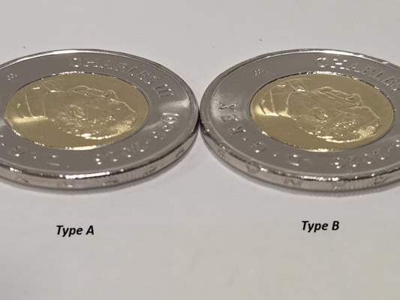
Note: This image show the faces (obverse) of toonies. Collectors view the edge lettering direction relative to the obverse orientations to classify a coin as Type A or Type B.

How Many Varieties Are There?
In terms of edge lettering orientation, there are two varieties for each edge-lettered toonie:
- Type A — Lettering upright when obverse side is shown.
- Type B — Lettering upright when reverse side is shown.
These are not separate official issues — just natural varieties created by how coins enter the edge lettering press. Collectors often seek both orientations, but they are functionally the same denomination and design otherwise.

Other Notes on Edge Lettering
- Some coins may show slight dimples or rim marks where the edge lettering press impacted the coin. This is a by-product of the process, not damage.
- Rare error coins or missing-lettering variants (if produced) are extremely collectible but uncommon.

So What Does This Mean For The Collector?
- Basically, it depends on the individual collector. How deep they go with their collection.
- If you only want the basics, just collect one of each coin; irregardless of type.
- If you look for or want varieties, then you may want to have one of each of the Type A and the Type B Toonie.
- There is no right or wrong way to collect coins.

References
- Royal Canadian Mint: Specifications and security features of the $2 Toonie, including edge lettering. Royal Canadian Mint
- Saskatoon Coin Club: Documentation on Type A vs. Type B edge lettering varieties. Saskatoon Coin Club
- Collector discussions & observations on how edge lettering appears depending on coin orientation. Numista

The Arnprior Silver Dollar

By Jim Austin
The Arnprior silver dollar is not a separate coin type with a different face value — it’s a collectible variety of the Canadian silver dollar struck by the Royal Canadian Mint (RCM). These dollars are the same 80% silver, 20% copper coins issued in the early to mid-20th century, featuring the classic Voyageur canoe design on the reverse. (Cavac)
What makes certain dollars “Arnprior” is a distinct die variation — specifically how many water lines appear in front of the canoe.

How the Name “Arnprior” Came About
In December 1955, the RCM struck about 2,000 silver dollars for a company in Arnprior, Ontario. These coins were found to have only 2½ water lines to the right of the canoe instead of the usual four. Collectors adopted the name “Arnprior dollar” after the town where the coins were first recognized, and the name has since been used to describe similar short water line varieties on other dates. (Wikipedia)
Arnprior vs. Regular Silver Dollar
The main difference between a regular silver dollar and an Arnprior variety lies on the reverse side (the canoe side):
Water Lines
- Regular silver dollar: Shows four full water lines in front of the canoe. (Cavac)
- Arnprior variety: Shows 2½ (or sometimes 1½) water lines — the bottom water line is absent and the middle may be partial. (Cavac)
A helpful way to see this is with a magnified comparison showing exactly where to count the lines:

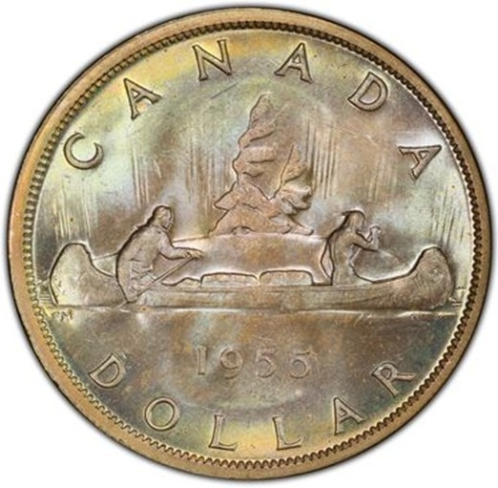
Example of a silver Arnprior dollar where the lower lines have been partially or fully polished away on the reverse.
To count them, focus on the area to the right of the canoe’s bow — the shallow horizontal lines represent the water. Compare how many distinct lines reach back toward the canoe.
Other Markers That Collectors Watch
While water lines are the key feature, some Arnprior silver dollars — especially the 1955 issues — may also show a die break on the obverse (front): a tiny raised line joining the T and I in the word “GRATIA.” Collectors often consider this a bonus feature for value, though not all short water line coins have it. (Cavac)

Why Arnprior Varieties Matter
Even though these dollars are still legal tender with the same silver content as regular dollars, the rarity of certain water line configurations can make them more desirable to collectors. Coins with:
- Very short water lines (like the classic Arnprior pattern),
- Minimal die wear, and
- Special obverse features (like a die break),
can sometimes command higher prices than common examples.

Summary of Key Differences
Feature | Regular Silver Dollar | Arnprior Variety
Water Lines on Reverse | Four full lines | 2½ or 1½ lines
Origin of Name | None | Linked to Arnprior, Ontario shipment
Collector Interest | Standard | Higher due to rarity
Die Break (Obverse) | Typically none | May be present on some (e.g., 1955)

References
- Canadian silver dollar die varieties and water lines — technical explanation of how die polishing created short water line variants and how the Arnprior term became attached. (Cavac)
- Arnprior origin story and collector history — narration of how these coins were linked to Arnprior shipments and how collectors use the term. (Wikipedia)
- Collector identification details — discussion of classic Arnprior features like 2½ water lines and optional die break features. (Collectors Universe)

Buy/Sell/Trade:
C-K Coin Club members in good standing are encouraged to submit ads to buy or sell numismatic and related items At the moment, there is no cost to place an ad.
Another ad can go here.
Wanted: Wooden money. Particularly from SW Ontario, but any from Canada. Call Jim @ 226-627-6789
Your ad can go here

