  - Chatham-Kent Coin Club

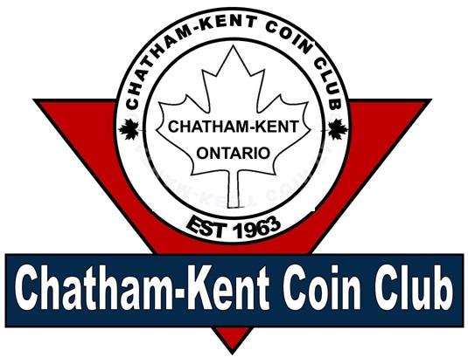
Vol 1 Issue 3 March 2026

President: Jim Austin
Editor: CKCC Executive
CKCoinClub.com
Newsletter@CKCoinClub.com
Published: Monthly
Next meeting is March 11, 2026 at John McGregor Secondary School Library, 300 Cecile Avenue Chatham

Inside this Issue
Page 1 Presidents Message
Page 2 Report of the Secretary
Page 4 Wooden Money: A Fun and Fascinating Corner of Numismatics
Page 10 Canadian 50 Cent Coin: 1982 Large vs. Small Bead Varieties
Page 12 Buy, Sell, & Trade

Presidents Message:
WHAT’s going on

Welcome to the newsletter.

Due to the school being closed (Winter Break) on our regular meeting night, we will be meeting on the Wednesday before; that is, March 11 instead of March 18.

Our coin show is fast approaching (March 29) and you know that means we are looking for volunteers. If you are able to help, please let us know. Specifically, we need help at 7:00 AM on the 29th to get tables in and placed. We will only have about an hour to get them placed as the dealers need time to set up their wares. We also need volunteers who have the red “committee” shirt who can help out during the show itself, even if only half the day. Basically what’s needed from you is to walk the floor and be available to anyone who needs a hand, ie getting a coffee for a dealer or directing an attendee to washrooms or whatever is needed. Even taking a turn sitting at the club table to talk with anyone who may have questions about the club or coin collecting. Everyone will have time to visit all the dealers.

It was disappointing that the Metal Detect people were unable to come to our February meeting. I am following up with them to arrange another date. However, even with them canceling very last minute, we still had a great meeting.

Lastly, I want to remind everyone that our website is becoming quite a resource for numismatists. Presently, we have 39 Canadian coin clubs listed. If you ever have the opportunity to go to an area that has one, it would be fun to go to a meeting. We also have a lot of organizations (websites) listed that you might find beneficial in your collecting activities. So, please, be sure to check out our link page at https://ckcoinclub.com/links
Happy Collecting,
Jim Austin

Report of the Secretary: Richard Sadler
Meeting Notes from #609 Feb-18 2026

Next meeting Wednesday March 11th 2026 7pm-9pm
In the Library at John McGregor Secondary school (300 Cecile Ave)

The meeting was brought to order by President Jim Austin with 22 members and one guest in attendance. Richard Sadler read the minutes from our January meeting and reminded everyone that the newsletters are now posted on our website (https://ckcoinclub.com). If you have any issues with accessing the Website, please ask us and we’ll work through any issues with you. Jim mentioned that there are many relatable stories on the website and if you’ve read or written one that you’d like to include please contact Jim. Another feature Jim would like to add, is that if you’ve been unable to find a particular coin or bill, you could have it listed in the newsletter that you are looking for it, and maybe you’ll be able to make a connection with someone that has the item.
We were supposed to have a presentation from the Medal Detection group, but they were forced to cancel at the last minute. Jim remains in contact with them to arrange a new date. Several members have seen their presentation and think it is worth it. In a related topic, Colin spoke about a person he has a connection with in Europe that participates in medal detection, and sells his “bulk” finds to Colin. Colin typically does get some old coins from this venture, and one of the items he sees regularly is “Celtic Bronze Ring money”. These date from approx. 800 to 50 BC and used as currency among the Celtic tribes from the Danube River region, to Eastern Europe, France, Spain, Britain, Wales, Scotland and Ireland. There are no identifiable markings on them and value was based on their size. They basically look like a bronze “O” ring.
Due to March break our March meeting will be held on the second Wednesday (March-11). With the early meeting date, Colin is unsure that he will have the coins we sent for grading back for this meeting. Colin will bring them to the coin show on March-29 or to the April-15 meeting for you to get your coins.
Paul advised us on the show plans. All show plans and advertising are being finalized and all Dealer tables have been sold, with Paul continuing to collect the table fees. Keep an eye out for our large street sign to promote the show, which will be on Richmond across from the casino. Paul continues to co-ordinate the volunteers required to make this show another success. If you can help moving tables, that’s great, but if you suffer from muscle pain, than we could use you as security to be a “set of eyes” around the parking lot while the dealers unload in the morning or load up at the end of the day. Please support our club and sign up with Paul. Thank-you. Paul has the door prizes, and Dennis will take care of the coffee vouchers we provide to the dealers and those that volunteer at the show. Please post and hand out the show flyers, Paul has passed out at the meetings to promote our show, and if you need more contact Paul (289-228-2817).
We continue to have a few items for our auction table at the meetings, but more participation would be appreciated and give a wider range of items to purchase. February had items, from coins, and bills to coin books and a nickel set. Please review your collection and bring in what you can.

Please note: March meeting is the second Wed. due to March Break March 11th

Raffle: Paul Robb
Door Prize: Marv Stamcoff
Did you know that the polar bear on the reverse of the Toonie has a name?
The mint named it “Churchill”

Wooden Money: A Fun and Fascinating Corner of Numismatics
By Jim Austin

What Is Wooden Money?
When most collectors think about money, they picture coins or paper notes printed by a government.
When people hear the term wooden money, the first reaction is often a chuckle. After all, money is supposed to be metal or paper, right? But wooden money has been part of North American collecting culture since at least 1931, and it holds an important place in both numismatics and exonumia.
Wooden money usually refers to wooden tokens or wooden nickels, often round but sometimes square or unusually shaped. They were issued as souvenirs, advertising pieces, emergency money, commemorative items or local trade tokens. They were never legal tender issued by governments, but they were often accepted locally or handed out to mark special occasions.
Early wooden tokens were usually imprinted with the denomination of five cents. This gave rise to the famous expression "Don't take any wooden nickels.", however, the denominations could also include 25¢, 50¢ and $1 and anything else the issuer decided.
For collectors who enjoy history, storytelling, and variety, wooden money offers something different: history you can hold, unusual designs, and a collecting field that is still affordable and approachable.

A Brief History of Wooden Money
Wooden money has its roots in hard times and creative marketing.

Early Emergency Issues
The earliest and most famous period for wooden money was during the Great Depression of the 1930s in the United States. Cash shortages forced towns, merchants, and local organizations to get creative. In some cases, wooden tokens were issued as emergency scrip, redeemable for goods or services locally.
These pieces weren’t meant to last forever. Wood was cheap and readily available, making it a practical solution when metal tokens were too expensive to produce.
Canada was a little slower to produce wooden tokens, not appearing until the around the early 1950’s

Souvenirs and Advertising
Eventually, wooden nickels became popular as advertising giveaways. Businesses handed them out to promote stores, fairs, expositions, and tourist attractions. The term wooden nickel itself became slang for something of little value—but collectors today know better.

Expositions and World’s Fairs
Wooden money was especially popular at World’s Fairs, exhibitions, and centennial celebrations. These tokens were sold or given away as keepsakes, often featuring local landmarks, dates, or slogans.

Modern Issues
Wooden money didn’t disappear after the Depression. In fact, it continues to be produced today for:
- Coin clubs
- Numismatic conventions
- Anniversaries
- Fundraisers
- Tourist attractions
Modern wooden tokens often feature laser engraving, color printing, and with more elaborate designs than their early counterparts.

Shapes and Sizes: More Variety Than You Might Expect
While many people imagine wooden money as simple round discs, the reality is much more interesting.

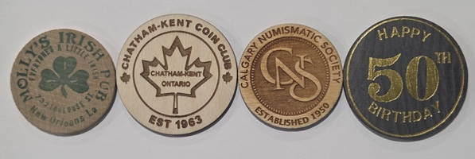
Round Tokens
The most common shape is round, typically the size of a nickel, quarter, or silver dollar. These often closely resemble coins and are popular with traditional coin collectors.

Photo courtesy Jim Austin

Square and Rectangular Pieces
Square wooden tokens are less common but highly collectible. Rectangular pieces were often used as admission tokens or advertising coupons or promotional pieces.
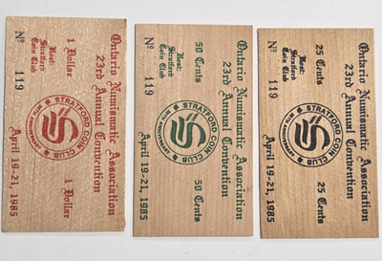
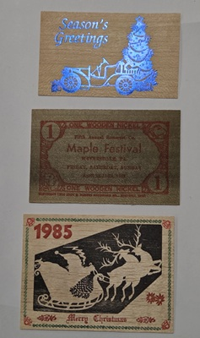
Photo courtesy Jim Austin Photo courtesy Jim Austin

Unusual and Novelty Shapes
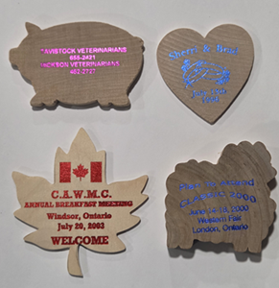
Some issuers got creative, producing tokens shaped like:
- Shields
- Houses
- Trees
- Animals
- State or Provincial outlines
- Hearts
These novelty shapes are especially popular with thematic collectors.

Photo courtesy of Jim Austin

How Wooden Money Was Made
Early wooden money was usually made from birch, maple, or other light woods. The designs were applied in several ways:
- Ink stamping (most common for early pieces)
- Burned or branded designs
- Pressed or Carved lettering
- Modern laser engraving common after the 1970’s
Because wood is an organic material, condition can vary greatly. Cracks, warping, stains, and fading are all part of the challenge—and charm—of collecting wooden money.

What Do Collectors Look For?
Just like coin collecting, wooden money collectors focus on several key factors.

Condition
Sharp lettering, minimal cracking, and legible printing are desirable. However, minor flaws are expected, especially on older pieces.

Age
Great Depression-era wooden money is especially sought after, particularly pieces dated between 1930 and 1939.

Scarcity
Some wooden tokens were produced in small quantities for local events and were never meant to survive. These can be surprisingly rare today.

Design and Theme
Popular themes include:
- Railroads
- Banks
- World’s Fairs
- Coin clubs
- Political campaigns
- Tourist attractions

Collecting Themes and Specialties
One of the joys of collecting wooden money is the ability to specialize.
Some popular collecting themes include:
- Depression-era wooden money
- Canadian wooden tokens
- Coin club issues
- Exposition and fair souvenirs
- Advertising wooden nickels
- Holiday or anniversary tokens
- 1967 Centennial Wooden Money

Many collectors enjoy mixing wooden money into their broader exonumia or token collections.

Storage and Care
Because wooden money is more fragile than metal, storage is important.
Best practices include:
- Store in a dry environment
- Avoid high humidity and temperature changes
- Use archival-quality holders or envelopes
- Never seal in airtight plastic if moisture is present
- Never clean wooden tokens. Cleaning can remove ink, damage the surface or lower collector value

Values and Affordability
One of the biggest appeals of wooden money is its affordability. Many pieces can still be found for just a dollar. Scarcer or historically significant examples can sell for more, but overall, it remains a budget-friendly collecting area making this an excellent entry point for new collectors.
Values depend on:
- Rarity
- Condition
- Demand
- Historical significance

Why Wooden Money Deserves a Place in Your Collection
Wooden money captures moments in local history that metal coinage never recorded. From small towns and fairs to national celebrations, these pieces reflect community pride, creativity, and resilience. They also offer a fun break from traditional coin collecting.
Whether you’re a beginner looking for something different or a seasoned collector exploring exonumia, wooden money is a field worth exploring.

Canadian 50 Cent Coin: 1982 Large vs. Small Bead Varieties
By Jim Austin

Introduction
The Canadian 50 Cent coin from 1982 is a fascinating piece for numismatists, particularly because it features two distinct varieties: the large bead and the small bead versions. These differences are not merely cosmetic but also offer insights into the intricacies of coin minting processes. This article aims to provide a comprehensive analysis of these varieties, focusing on the key distinguishing features.

Queen's Hair Detail
One of the most noticeable differences between the large and small bead varieties is the detailing in the Queen's hair. On the small bead variety, the hair is more intricately detailed, with finer lines and a more textured appearance. This added detail gives the Queen's portrait a more lifelike and three-dimensional quality. In contrast, the large bead variety has less detailed hair, appearing smoother and less pronounced. This difference can be attributed to the different dies used in the minting process.

Jewels on the Tiara
Another significant difference can be observed in the jewels at the very front of the Queen's tiara. For the large bead variety, there are two equal-sized jewels positioned on top of each other. This symmetrical arrangement gives the tiara a balanced and elegant look. On the other hand, the small bead variety features one larger jewel on top of a much smaller one. This asymmetrical design is a key identifier for distinguishing between the two varieties. Collectors often use this feature as a quick reference when sorting through their collections.

Design of the Bust
The bottom of the Queen's bust also varies between the two bead varieties. In the large bead version, the bottom of the bust is rounded, giving it a softer and more flowing appearance. The small bead variety, however, features a pointed bottom on the bust. This pointed design adds a certain sharpness and contrast to the coin's appearance, making it easily distinguishable from the large bead variety.

Bead Size and Distribution
The size and distribution of the beads around the edge of the coin are the most defining characteristics that separate the two varieties. The large bead variety, as the name suggests, features larger beads that are evenly spaced around the coin's perimeter. These larger beads create a bold and striking border that frames the coin's design elements effectively. In contrast, the small bead variety has smaller beads that are more closely spaced. This denser arrangement of smaller beads gives the coin a more delicate and intricate border.
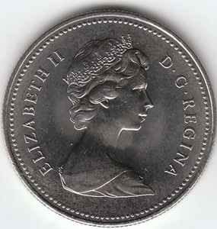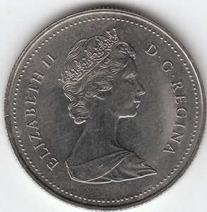
Large Bead Small Bead

Historical Context
Understanding the historical context of the 1982 Canadian 50 Cent coin adds another layer of appreciation for these differences. The early 1980s were a time of technological advancements in coin minting, with new techniques and tools being introduced. The large and small bead varieties reflect these changes and the experimentation that took place during this period. Collectors value these coins not only for their aesthetic differences but also for their historical significance.

Collecting Tips
For those interested in collecting the 1982 Canadian 50 Cent coin, there are a few tips to keep in mind. First, always examine the Queen's hair and the jewels on the tiara under good lighting and with a magnifying glass. These features are the easiest to spot and can quickly help you identify the variety. Next, pay attention to the bottom of the bust, as this feature is another clear indicator. Lastly, the bead size and distribution around the coin's edge should be carefully observed. Keeping these tips in mind will help you build a well-curated and authentic collection.

Conclusion
The 1982 Canadian 50 Cent coin is a remarkable example of numismatic variety and historical significance. The large and small bead varieties offer collectors a unique opportunity to appreciate the subtle differences in design and detail that make each coin special. By understanding and recognizing these differences, collectors can deepen their appreciation for the art and science of coin minting.
In summary, the next time you come across a 1982 Canadian 50 Cent coin, take a closer look at the Queen's hair, the jewels on the tiara, and the bottom of the bust. These features tell a story of a time when coin design was evolving, and they serve as a testament to the craftsmanship and artistry that go into creating currency. Happy collecting!

Buy/Sell/Trade:
C-K Coin Club members in good standing are encouraged to submit ads to buy or sell numismatic and related items. There is no cost to place an ad.
Looking for something you are having a hard time finding? Place a free ad here. Let our readers help you find it.
Wanted: Wooden money. Particularly from SW Ontario, but any from Canada. Call Jim @ 226-627-6789
Be the next to place an ad. No charge.

