  - Chatham-Kent Coin Club

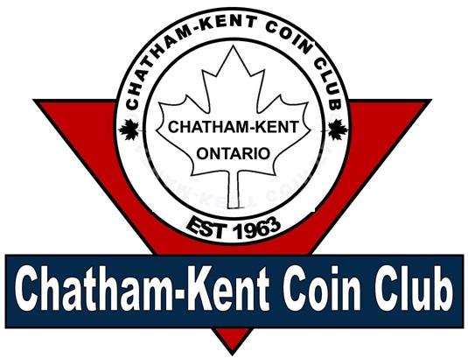
Vol 1 Issue 5 May 2026

President: Jim Austin
Editor: Jim Austin
CKCoinClub.com
Newsletter@CKCoinClub.com
Published: Monthly
Next meeting is May 20, 2026
at John McGregor Secondary School Library,
300 Cecile Avenue Chatham - 7 PM

Inside this Issue
Page 1 Presidents Message
Page 2 Report of the Secretary
Page 4 The Canadian $25 Banknote
Page 8 Dealer Ads
Page 9 Buy, Sell, & Trade
Page 10 Upcoming Coin Shows

Presidents Message:
WHAT’s going on

Welcome to the newsletter.

Spring is here and summer isn’t far behind. That means that we are full on into coin show season. There are a lot of them within a 4 hour drive and I am planning on attending some of them. Hopefully, you can too. I have added a section for coin shows in this edition and will continue listings in future editions as well.
This coming meeting on May 20, we will be having a short presentation on Canada’s Large Cents. We will open up the floor for discussion and questions after the presentation.

Lastly check out the resources on our website. You never know what you will find there to enhance your collecting or knowledge. Again, the resource page is https://ckcoinclub.com/links .

At this time, we will not be including coin shows on the website except for our immediate surroundings. However, there are all the coin clubs I could find so far and you can check out their pages for shows.
Happy Collecting,
Jim Austin

Report of the Secretary: Richard Sadler
Meeting Notes from #611 April-15 2026
Next meeting Wednesday May 20th 2026 7pm-9pm
In the Library at John McGregor Secondary school (300 Cecile Ave)

The meeting was brought to order by President Jim Austin with 17 members in attendance. Jim mentioned again that if you would like to add a numismatic story to our website, please reach out to Jim and he will arrange to include it.
Jim included a story and “news links” this month for the recent circulation of counterfeit $100 bills. Member Steve Maceyovski heard that a couple of those bills were used at the Grocery chain where he works. He advised management about Jim’s story and links, and because of that, the store is teaching the staff of what to look for. This is proof that our website and Jim’s efforts are valuable and effective.
Jim also asked all the coin dealers from our club, to provide Jim with their contact information and Jim will include that on the website, giving them a bit of free advertising.
Richard Sadler reviewed the minutes from our March meeting focusing on the coins members sent for grading. As hoped for, Colin has able to pick up the coins from ICCS prior to the show, and all have been distributed back to the owners. Colin plans to send another lot to ICCS by the end of May this year if he can get a lot of 100 coins and again in December. If this is something you are interested in participating, please reach out to Colin (ccutler2024@outlook.com or phone 519-358-5506). Time is running out for the May deadline so don’t delay. Thank-you Colin for organizing. Colin did mention that ICCS will not grade English tokens or error coins. Werner mentioned that CCCS grading in Quebec will grade error coins. Colin and Werner both agreed that they are happy with CCCS grading, but within the general dealer population ICCS is regarded better than CCCS. The Windsor coin club does send coins to CCCS a few times a year, so if you want error coins graded, please talk to Werner at one of our meetings.
Richard also brought up the topic of rising bullion prices and the effect on the hobby. With silver spiking at about $160 before settling around $100 an ounce, coin prices have spiked over the last few months. If silver stays at these prices, there’s no issue, but if silver drops back down to “pre-stock market” turmoil, prices, buyers will be losers. Another concern is that the coins are worth more as bullion and less about historic value, which leads many to be sent to the smelter and turned into silver ingots, and lost forever. Colin mentioned that the smelters are backed up and therefore bullion dealers aren’t even offering “spot price” for the silver content of the coins. At $100 an ounce, silver dollars have about $60 spot price of silver, but most dealers are only offering about $37 for them, although still selling them at the $60 price. As an option, Gatewest coins in Winnipeg offers $50 for the same coin. Even with shipping costs, this may be a better option for sellers. This leaves collectors in a tough spot, as they’re creating a loss for themselves as they build up their collection. With the buy/sell price difference dealers are buying all the silver they can, until collectors refuse to absorb the complete loss. Some collectors see a bigger payout, than they’ve seen in the past, but fail to realize there may be more to gain once the smelter backlog eases and demand goes up. Again this could all change if bullion returns to early 2025 pricing. Do you hold or sell.
Treasure Paul Robb delivered our financial report and spoke about our coin show. Paul was thrilled with the support and participation of the membership to come out and assist to create another successful show. We had 15 members come out to assist, and an attendance of 184 through the doors. We were down slightly from last year, but the dealers were happy with their sales and want to come back. There was even interest in again hosting a second show in the fall, but for now we want to continue to focus on just one show in the spring. Paul advised that our show expenses were $1610.00, while we brought in $2300.00, giving us a profit from the show of $690.00 which will keep our club financially viable for another year. Even though we weren’t able to set up the night before, we had all tables in place by 7:45am giving dealers plenty of time to setup and trade amongst themselves before the public came in at 10am. Dennis Maceyovski expressed on behalf of the club, his thanks to Paul for being the show organizer.
Raffle: Glenn Lotz
Door Prize: Damian Nussio
Did you know: In 1935, the Bank of Canada issued a 25 dollar banknote to commemorate the Silver Jubilee of king George V.

The Canadian $25 Banknote

By Jim Austin

The Canadian $25 banknote was a one-time commemorative issue, printed in 1935 to mark the Silver Jubilee of King George V, and it remains one of the most unusual notes ever produced by the Bank of Canada. It was issued only that year, withdrawn from circulation in 1937, and it was the only $25 note ever released by the Bank of Canada.
The note was created as a tribute to the 25th anniversary of King George V’s accession to the throne, which was celebrated in 1935. That made it a special-issue commemorative banknote rather than a regular circulating denomination intended to become part of Canada’s standard currency system. The Bank of Canada used the occasion to produce a note that was both symbolic and collectible, which was unusual for a federal banknote issue at the time.
The $25 note was issued on May 6 1935. Sources on the 1935 series indicate that the first Bank of Canada notes began circulating on March 11 1935, but the $25 commemorative was a separate release within that first series. It was printed only in 1935 and withdrawn from circulation on May 18 1937.
The note was a very short-lived issue. It was printed only during 1935, with circulation lasting until 1937, so its active life as a circulating banknote was roughly two years. Because it was never intended as a long-run denomination and was never repeated in later series, the $25 note occupies a special place in Canadian paper money history.
The exact total printed varies slightly by source depending on whether the count is given by language version or as a combined issue. One source reports 140,000 issued notes for the English version, while another states that 160,000 notes were issued in total across both English and French versions. What is consistent across the sources is that this was a limited run, far smaller than standard circulation notes, and many surviving examples are now scarce collectibles.
The note was printed in a royal purple color, which matched its commemorative purpose and made it stand out immediately from ordinary Canadian banknotes. On the front, it featured portraits of King George V and Queen Mary, while the back showed Windsor Castle, one of the royal family’s official residences. The obverse was engraved by Edwin Gunn and Will Ford of the American Bank Note Company, and the reverse image of Windsor Castle was engraved by Louis Delmoce, also of the American Bank Note Company.
The note also reflected the design practices of the first Bank of Canada series. It carried bilingual production in separate English and French versions, rather than a single bilingual note, which was a unique feature of the 1935 series. The design included the issue date of May 6 1935 and the anniversary years 1910–1935, reinforcing the Silver Jubilee theme. It was printed by the Canadian Bank Note Company.
The $25 note was printed on sheets of four, and each note on a sheet shared the same red sheet number. To distinguish the positions of the four notes on each sheet, the printer added black “check letters” A, B, C, or D. That detail is useful to collectors because it helps identify the note’s layout position on the sheet and explains some numbering variations seen today.
The note measured about 152 x 73 mm according to one catalog source. It had no watermark and no security thread, which was normal for many notes of that era. Its color scheme, portraits, and castle vignette gave it a distinctly ceremonial appearance, setting it apart from the more functional look of ordinary denominations.
The Canadian $25 note was the first commemorative banknote issued by the Bank of Canada. It is also the only $25 denomination ever issued by the Bank of Canada, which makes it a singular item in Canadian currency history. Because later banknote series did not continue the denomination, the note became a brief but memorable experiment in commemorative paper money.
Its rarity is part of its appeal. The note was never printed in large quantities, and surviving examples are much scarcer than notes from standard denominations. Collector references describe it as one of the most sought-after notes in the 1935 series, especially because of its dual portraits, short issue window, and royal theme.
The $25 note was withdrawn from circulation in 1937, only two years after issue. The next Canadian banknote series, introduced in 1937, moved toward greater uniformity and did not repeat the commemorative $25 denomination. In that sense, the note became both a historical marker and a dead-end in denomination history: a unique issue that was never revived.
Collectors value the note for several reasons. It is the only Canadian banknote denomination of its kind, it commemorates a major royal milestone, and it belongs to the first Bank of Canada series, which itself has strong historical appeal. The separate English and French versions also add interest because the 1935 series was the only Bank of Canada series to use unilingual banknotes in this way. That combination of rarity, design, and historical context makes the $25 note a centerpiece in many Canadian paper-money collections.

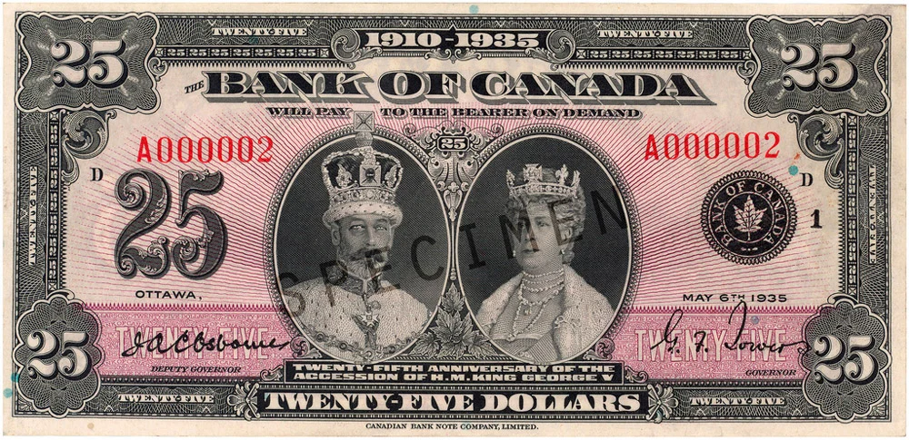
The obverse of the note shows the dual portraits and the distinctive purple design that made it instantly recognizable.
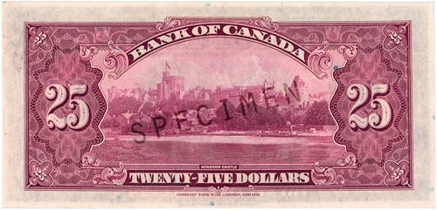
The reverse features Windsor Castle, tying the note directly to the Silver Jubilee theme and the monarchy it celebrated.
References
- Bank of Canada Museum, “First Series $25 Commemorative Note”
- Bank of Canada, “Commemorative notes”.
- Coins and Canada, “The First Bank of Canada Notes: 1935”.
- Numista catalog entry for Canada 25 dollars 1935.
- Coins and Canada price guide for 25 dollars 1935.

Business Card Ads: Any CK Coin Club dealer may submit their business card for inclusion in this section.

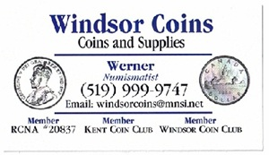

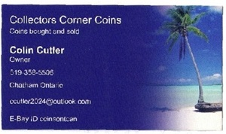

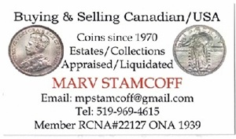



Buy/Sell/Trade:
C-K Coin Club members in good standing are encouraged to submit ads to buy or sell numismatic and related items. There is no cost to place an ad
Looking for something you are having a hard time finding? Place a free ad here. Let our readers help you find it.
Wanted: Wooden money. Particularly from SW Ontario, but any from Canada. Call Jim @ 226-627-6789
Be the next to place an ad. No charge.
Am looking for Canada Specimen Sets, 2010 Northern Harrier, 2014 Baby Rabbits, 2015 Baby Racoons if anyone has them to bring to the meetings. Colin

Upcoming Coin Show:

Cookstown Coin Show May 24, 2026

Cookstown Curling Club, 18 Church Street (Hwy 89), Cookstown, ON, L0L 1L0

Hours are 10 a.m. to 3 p.m. 40+ tables of coins, paper money, gold, silver, supplies and other exciting items for sale. Looking to sell some of your collection? Coin dealers will make you an offer on-site. Kid’s table, free parking, admission by donation, bring the family and spend the day in town! 45 minutes north of Toronto, three minutes west of Hwy 400 on Hwy 89. Note**There are stairs to enter show.

Name: Cassidy Stroud
Phone: 519-427-6158
Email: simcoecurrencyclub@gmail.com
Web: http://www.simcoecurrencyclub.com

64th Annual Ontario Numismatic Assc. Convention May 29, 2026 to May 30, 2026

Ottawa Conference & Event Center, 200 Coventry Rd, Ottawa, ON,
The ONA’s 64th Annual Convention and Coin Show returns to Ottawa. The convention will feature a multi-day bourse along with educational symposiums, specialty club meetings, a kids’ table and auction, and the ONA’s general meeting. A special room rate is available at the Hampton by Hilton, which is attached to the Ottawa Conference Centre. Visit the ONA website for full details.
Name: Robb McPherson
Phone: 519-577-7206
Email: treasurer@the-ona.ca
Web: https://www.the-ona.ca/upcoming.php

London Numismatic Society Annual Coin Show June 7, 2026

Ramada London, 817 Exeter Road, London, ON, N6E 1W1

One day show hosted by the London Numismatic Society. Twenty-six dealer tables offering coins, banknotes, tokens and literature for sale. Free evaluations offered by member experts. 9 a.m. to 3 p.m. Free parking and door prizes. Admission is $5, children under 16 are free.

Name: Ron Confortin
Phone: 519-636-0862
Email: Rconfortin39@gmail.com

Brantford Numismatic Society Coin Show
June 14, 2026
Brantwood Community Centre, 238 Brantwood Park Rd, Brantford, Ont
Our annual show and sale will be from 9 am to 3 pm. Entrance is at the back. We will be featuring something for everyone, Canadian coins, notes, tokens as well as worlds and US, bullion, and militaria. We have free parking, food on site and admission is by donation to the club.
Contact: Chris Liantzakis
Phone: 416-804-2021
Email: branfordcoinclub@gmail.com

Oxford Annual Coin Show June 28, 2026
Oxford Auditorium, 875 Nellis St, Woodstock, On
Last year’s show hosted 77 tables of coins, bank notes, bullion, tokens and numismatics. This year’s expansion allows capacity for 100+ tables. Hours are 9 am to 3 pm. Buy, sell, trade and evaluate. Kids table, free parking and kitchen open for food and drinks. Admission is $4 with a chance to win a .999 pure gold coin. Hosted by the Woodstock and Ingersoll Coin Club.
Contact: John Tryhub
Phone: 519-608-8446
email: john@woodstockgol

